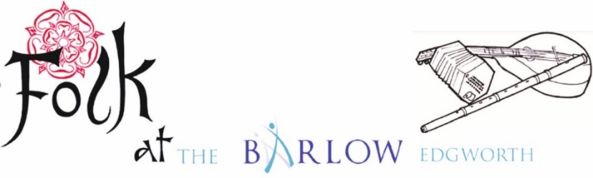 **TICKET BOOKING FORM**

**www.folkatthebarlow.com**

***Event* : 13th Edgworth Folk Festival : Fri 4 – Sun 6 Oct 2024**

***Venue* : The Barlow, Bolton Rd, Edgworth BL7 0AP**

* **Adult tickets are for all adults, including senior citizens**
* **Junior tickets are for under 16’s, who must be accompanied by a responsible adult at all times**
* **Student tickets are for students/pupils aged 16-21**
* **Full Weekend Ticket £40 up to 6 Sept (£45 after)**

|  |  |  |  |
| --- | --- | --- | --- |
|  | **Price per ticket** | **No of Tickets** | **Total Cost** |
| **Full Weekend Ticket** | **£40/£45** |  |  |
| **Saturday Ticket** | **£30** |  |  |
| **Friday Evening Ticket** | **£10** |  |  |
| **Sunday Ticket** | **£20** |  |  |
| **Saturday Daytime only** | **£20** |  |  |
| **Saturday Evening Concert** | **£15** |  |  |
| **Junior Weekend Ticket** | **free** |  |  |
| **Student Weekend Ticket** | **£20/£22.50** |  |  |
|  |

**Do you require a camper van space? If so, please confirm with Mike**

**on 07713 248067 before booking your tickets.**

**To Pay by Cheque Please print, fill in and post your form with a stamped addressed envelope and cheque made payable to “Folk at the Barlow” to : Edgworth Folk Festival, Hoyle Dean Farm, Coal Pit Lane, Rossendale BB4 9SA.**

**To Pay by Bank Transfer Please fill in and email your form to** [**folkatthebarlow@gmail.com**](mailto:folkatthebarlow@gmail.com) **and send remittance to**

Account Name **: Folk at the Barlow** Reference : **Your Surname and FEST (eg SmithFEST)**

Sort Code : **01-01-42** Account Number **: 23390573**

**Your Details**: (it’s important that we know how to contact you)

**Name : ……………………………………………………………………………………………………..**

**Email: ……………………………………………………………………………………………………….**

Please add my email address to the Folk at the Barlow mailing list. I understand that it will only be used for informing me of forthcoming events.

**Phone : …………………………………………………………………………………………**